Installation guide for LightGBM on windows (Source: <https://github.com/Microsoft/LightGBM/tree/master/R-package>)

1. Install git and CMake (<https://cmake.org/>)
2. Install RTools (<https://cran.r-project.org/bin/windows/Rtools/>)
3. Install Visual Studio (<https://visualstudio.microsoft.com/downloads/>)
4. Once visual studio is installed, open it
5. Go to Tools -> Get Tools and Features
6. Go to ‘Invidual components’ tab and select ‘Visual C++ tools for CMake and Linux’

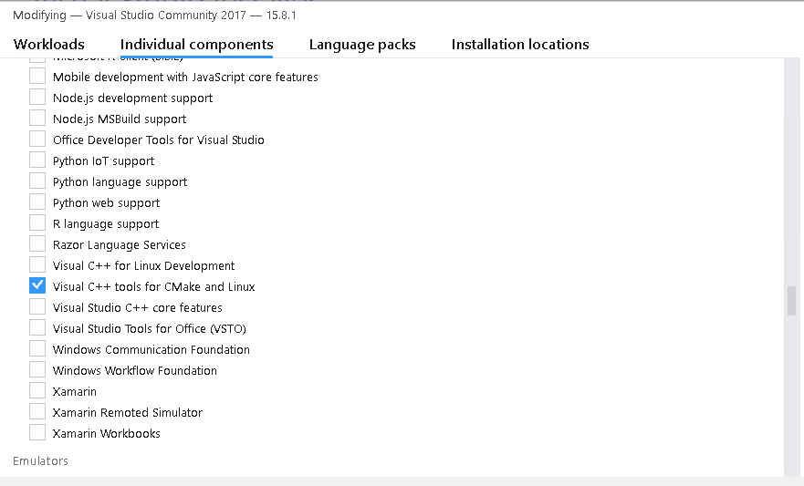

1. You might need to reboot your machine at this point
2. Add three things to the environment variable
   1. CMAKE (C:\Program Files\CMake\bin)

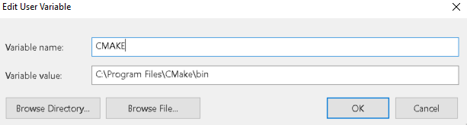

* 1. R (C:\Program Files\R\CranR-3.4.1\bin)
  2. RTOOLS_MGW64 (C:\Rtools\mingw_64\bin)
  3. Add the above three directories in the PATH variable

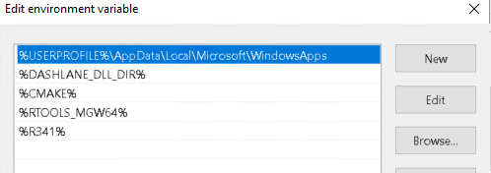

1. If you would like to use the GPU version, follow steps 10 – 12, otherwise, skip to step 13
2. download two additional programs:
   1. OpenCL for your GPU
      * For running on Intel, get [Intel SDK for OpenCL](https://software.intel.com/en-us/articles/opencl-drivers).
      * For running on AMD, get AMD APP SDK.
      * For running on NVIDIA, get [CUDA Toolkit](https://developer.nvidia.com/cuda-downloads).
   2. Boost library
      * Visual Studio 2015 -> msvc-14.0-64.exe,
      * Visual Studio 2017 -> msvc-14.1-64.exe.
3. Add boost library to environment path
   1. C:\local\boost_1_64_0\
   2. C:\local\boost_1_64_0\lib64-msvc-14.1
4. Set use_gpu to TRUE in R-package/src/install.libs.R
5. Open windows command prompt and run the following code:

*git clone --recursive https://github.com/Microsoft/LightGBM*

*cd LightGBM/R-package*

*Rscript build_package.R*

*R CMD INSTALL lightgbm_2.1.1.tar.gz --no-multiarch*

1. For GPU version, mess with variables

* device = "gpu" # no need to change
* gpu_platform_id = 0 # no need to change
* gpu_device_id = 1 # test 0 and 1 to find out which is GPU